Assignment 4 : Create Stored procedure in Northwind database to insert or update a

record in a table

-------------------------------------------------------------------------------------------------------------

Northwind_Database

https://github.com/microsoft/sql-server-samples/blob/master/samples/databases/northwind-pubs/instnwnd.sql

1. Create a stored procedure in the Northwind database that will calculate the average

value of Freight for a specified customer.Then, a business rule will be added that will

be triggered before every Update and Insert command in the Orders controller,and

will use the stored procedure to verify that the Freight does not exceed the average

freight. If it does, a message will be displayed and the command will be cancelled.

--stored procedure 1

create proc spGetAvgFreight

@cust_id varchar(15)

as

begin

select CustomerID, Avg(Freight) from Orders group by CustomerID having CustomerID=@cust_id

End

Output:



-- trigger

alter trigger message_pass

on Orders

for insert,update

as

begin

Declare @cust_id varchar(15)

select @cust_id=CustomerID from inserted

Declare @Freight float

select @Freight=Freight from inserted

if(Exists(select 1 from orders where CustomerID=@cust_id having avg(Freight) < @Freight))

begin

print('Freight is more than a Avg freight')

rollback

end

else

begin

exec spGetAvgFreight @cust_id

print('insertion is successful')

end

End

INSERT INTO Orders

VALUES ('CENTC', 7,'1996-07-04 00:00:00.000', '1996-08-01 00:00:00.000', '1996-07-16 00:00:00.000', 3, 3.18, 'Vins et alcools Chevalier', '59 rue de Abbaye', 'Reims',NULL,51100,'France')

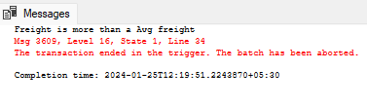

INSERT INTO Orders

VALUES ('CENTC', 7,'1996-07-04 00:00:00.000', '1996-08-01 00:00:00.000', '1996-07-16 00:00:00.000', 3, 1.18, 'Vins et alcools Chevalier', '59 rue de Abbaye', 'Reims',NULL,51100,'France')

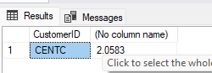

2. write a SQL query to Create Stored procedure in the Northwind database to retrieve

Employee Sales by Country

--stored procedure 2

create procedure spGetSalesByCountry

@country nvarchar(20)

as

begin

select e.EmployeeID, e.FirstName, e.LastName, count(e.EmployeeID) from Employees e

inner join Orders o on e.EmployeeID=o.EmployeeID

group by o.ShipCountry,e.EmployeeID,e.FirstName,e.LastName

having o.ShipCountry = @country

end

exec spGetSalesByCountry 'Finland'

Output:

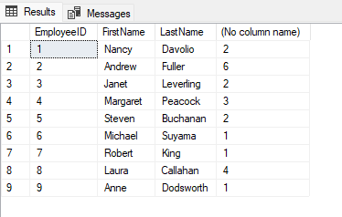

3. write a SQL query to Create Stored procedure in the Northwind database to retrieve

Sales by Year

--stored procedure 3

create proc spGetSalesByYear

@year int

as

begin

select count(year(OrderDate)) from orders where year(OrderDate)= @year

end

exec spGetSalesByYear 1996

Output:

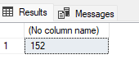

4. write a SQL query to Create Stored procedure in the Northwind database to retrieve

Sales By Category

--stored procedure 4

create proc spGetSalesByCategory

@Category nvarchar(20)

as

begin

select count(o.OrderID) from [Order Details Extended] as o

inner join Products p on o.ProductID=p.ProductID

inner join Categories c on p.CategoryID=c.CategoryID

where c.CategoryName=@Category

end

exec spGetSalesByCategory 'Beverages'

Output:

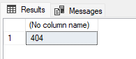

5. write a SQL query to Create Stored procedure in the Northwind database to retrieve

Ten Most Expensive Products

--stored procedure 5

create proc spGetExpensiveProducts

as

begin

select top 10 ProductName, UnitPrice from Products order by UnitPrice desc

end

exec spGetExpensiveProducts

Output:

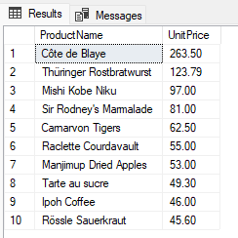

6. write a SQL query to Create Stored procedure in the Northwind database to insert

Customer Order Details

--stored procedure 6

create proc spInesrtOrderDetails

@OrderID int,

@ProductID int,

@UnitPrice float,

@Quantity int ,

@Discount float

as

begin

insert into [Order Details ]

values

(

@OrderID,

@ProductID,

@UnitPrice,

@Quantity,

@Discount

)

end

7. write a SQL query to Create Stored procedure in the Northwind database to update

Customer Order Details

--stored procedure 7

create proc spUpdateOrderDetails

@OrderID int,

@ProductID int,

@UnitPrice float,

@Quantity int ,

@Discount float

as

begin

update [Order Details ]

set UnitPrice=@UnitPrice, Quantity=@Quantity, Discount=@Discount

where OrderID=@OrderID and ProductID=@ProductID

end